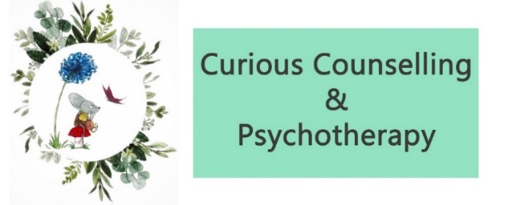

Anxiety management techniques and resources

By doing some exercises to strengthen your vagus nerve (which is responsible for heart rate, breathing amongst other things), you can help to stabilise your nervous system. Anxiety can feel overwhelming when your vagus nerve is weak and not stimulated.
A lot of anxiety reducing techniques are recommended to people in the throes of an anxiety attack – these are symptomatic responses and they can help but there needs to be some consistent practice of these exercises even when anxiety isn't present in order to increase your ability to mange anxiety when it is present.
Below are some exercises that I recommend doing on a daily basis if possible. Making them part of your daily routine, will not only benefit you in managing anxiety, but our brain feels safe in routine, in what it comes to know, so there's the added bonus of retraining your brain to a place of safety too.
- Belly breathing
- Lie on your back on a flat surface or in bed, with your knees bent and your head supported. You can use a pillow under your knees to support your legs.
- Place one hand on your upper chest and the other just below your rib cage. This will allow you to feel your diaphragm move as you breathe.
- Breathe in slowly through your nose so that your stomach moves out, causing your hand to rise. The hand on your chest should remain as still as possible.
- Tighten your stomach muscles, so that your stomach moves in, causing your hand to lower as you exhale through pursed lips. The hand on your upper chest should remain as still as possible.
- Square breathing
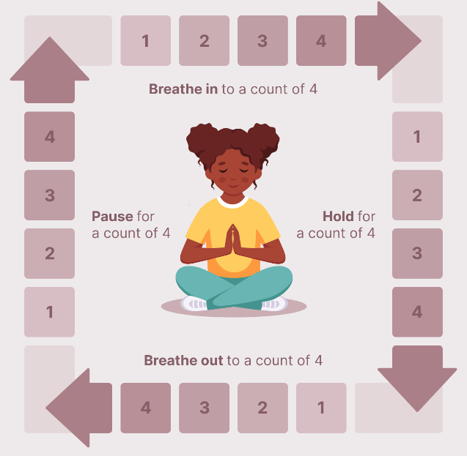

- Bi lateral stimulation
Bilateral stimulation refers to the process of alternately stimulating the left and right sides of your brain. Imagine it as a ping-pong game where the ball moves back and forth, stimulating one side of the table—or your brain—and then the other.
So grab something (apple, orange, tennis ball) that you can pass from side to side between your hands, whilst following with your eye. Continue this for a minimum of 5 minutes.
- Binaural beats music
This type of music can help to reduce anxiety because it generates sound in the alpha frequencies. Alpha waves occur between 8 and 12 Hz which indicates a relaxed but awake state. This type of music can induce calm and reduce stress. YouTube has a great source of this type of music so take your time to find some that you connect with.
- Havening technique
Applying Havening Touch and using our innate ability to generate delta waves in our brain, we are able to initiate a sense of calm. Delta waves are generated during sleep and are our natural wavs associated with relaxation.
Give yourself a hug – place the palms of your hands on your opposite shoulders and rub them down your arms to your elbows.
- Movement each day
Ensuring that you move your body in some way EVERY day will help to reduce anxiety too. Walking, running, yoga stretches - whatever is most suited to you. If the thought of doing anything too ambitious worries you, then doing some small movement at home is still beneficial. Tighten yourself up, tightening all your muscles whilst breathing in and then let go of the tension and blow air out.
- Meditation
Finding some meditations that work for you and spending some time each day listening to them will induce a sense of calmness. YouTube is a great place to find guided meditations. Spend some time finding someone who you can connect with, who’s voice has a relaxing impact on you and listen to their meditations regularly.

- In the moment techniques to help with anxiety.

1. Grounding - stimulate your senses. 5 things you can see, 4 things you can touch, 3 things you can hear, 2 things you can taste, 1 thing you can smell.
2. Engaging your conscious brain - distraction - have a conversation, read a book out loud, sing, research something online as examples.
3. Movement/exercise - move your body, stretch, also tighten yourself up into a ball really tight, let go and blow air out.
4. Controlled breathing – in through your nose and out through your mouth.

Useful apps to download
- Calm
- Insight Timer
- Balance
- Headspace

