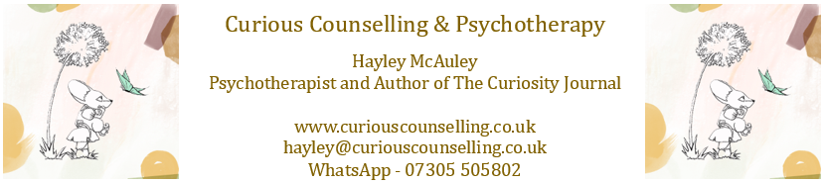
Stress reduction resource
Stress is a natural response to pressure or threat, but when it becomes overwhelming or long-lasting, it can have a significant impact on both the mind and body. Common effects include headaches, muscle tension, poor sleep, irritability, difficulty concentrating, and a weakened immune system. Recognising stress early and using simple strategies to manage it can protect both physical and emotional health.

Top 5 tips for reducing stress:
1. Deep breathing (4-7-8 Method): Inhale through your nose for 4 seconds, hold for 7, and exhale slowly for 8. Repeat 3–5 times to activate the body's relaxation response.
2. Progressive muscle relaxation: Starting from your toes, tense each muscle group for 5 seconds, then release. Work up through your body to reduce tension.
3. Mindful breaks: Take 2–3 minutes during your day to pause, notice your surroundings, and focus on your breathing. This helps ground you in the present moment.
4. Physical movement: Gentle exercise such as walking, stretching, or yoga boosts endorphins and reduces built-up stress hormones.
5. Healthy routines: Maintain regular sleep patterns, stay hydrated, and set aside time for activities you enjoy. Consistency supports resilience to stress.

How therapy can help:
While these techniques can ease stress day to day, therapy provides a safe space to explore the deeper causes of stress and develop long-term coping strategies. Working with a therapist can help you recognise unhelpful patterns, build healthier boundaries, and strengthen your ability to manage future challenges. Therapy can also support you in understanding the connection between stress and your overall wellbeing.

